Week 6 Lab Exercises

Exercise 6

I have given random state differnet values and it showed completely different clusters in different positions also all the nodes changed postion as well

random_state=1

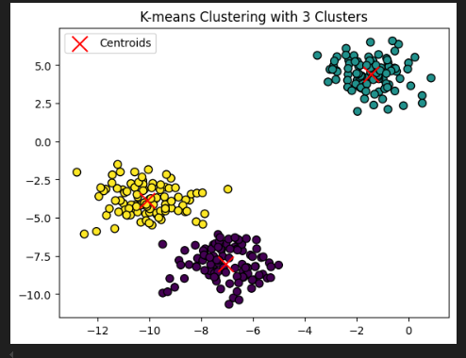

random_state=500

